*Computer networks practical experiments*

**EXPERIMENT NO—1::**

*Aim :* **configuring networks devices using packet racer.**

***Requirments:***

**1.switch/hub-interferecnce btwn two devices.**

**2.end devices-they are the devices through which we can pass msg from one end to other.**

**3.cable-for connection.**

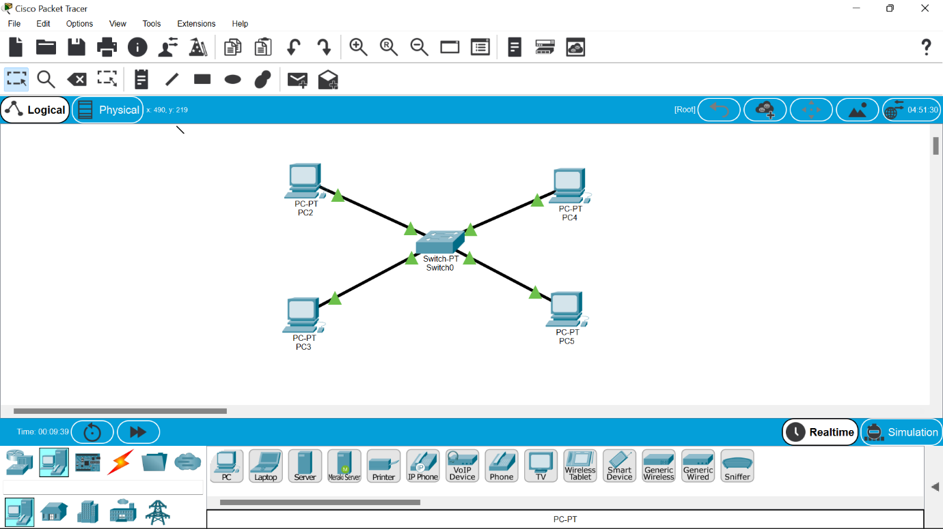

**Four systems are connected to switch using**

**Straight through cable.**

**Ip address will be provided to each system.**

***Procedure:***

**1.The main aim is to configure btwn network devices.**

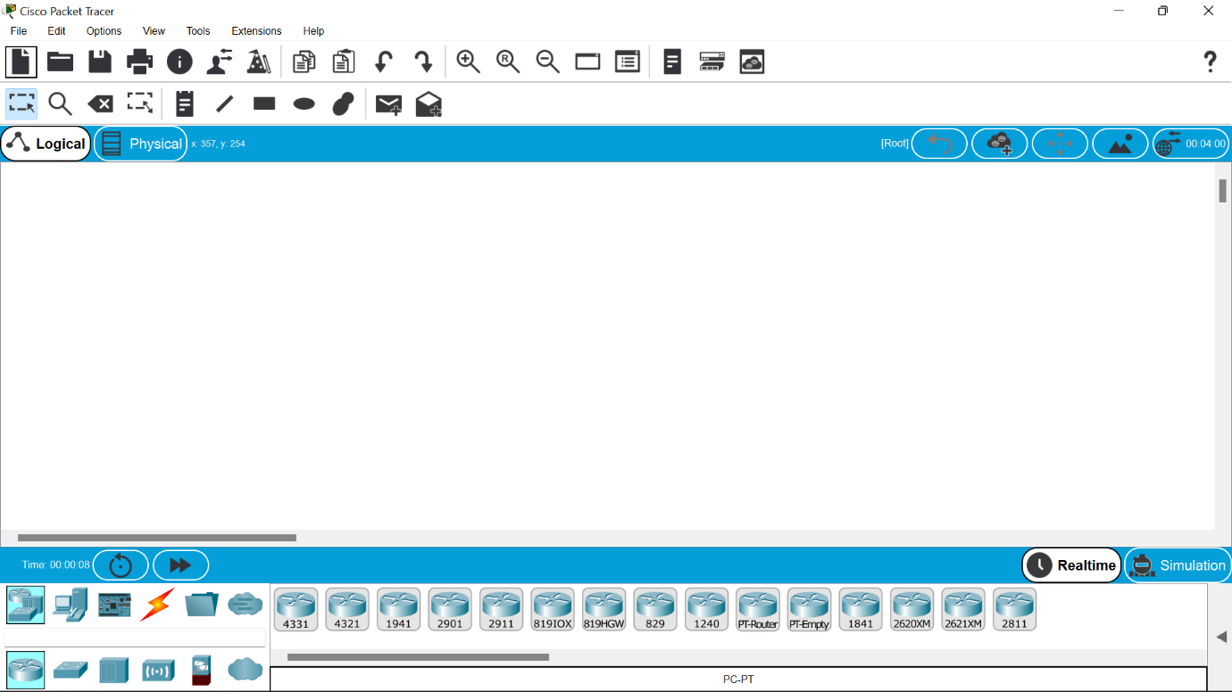

**2.the concept involved in this is ip addressing and address resolution protocol(arp).**

**3.click on the end devices and select pc and drag and drop on the window .**

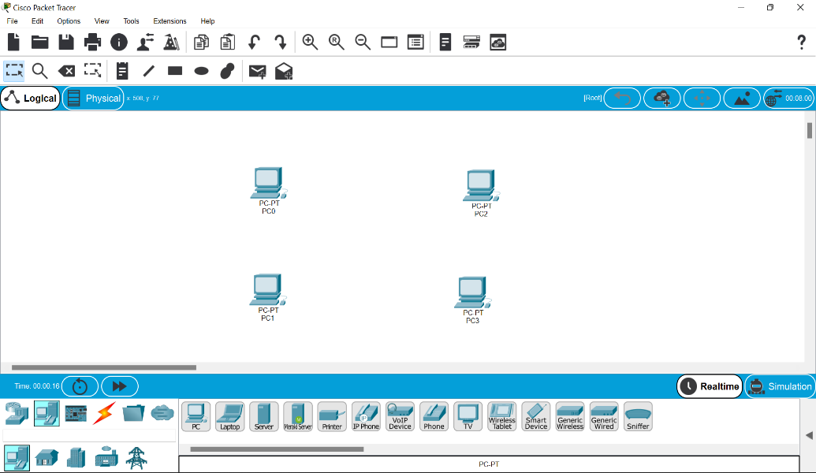

**4.select the switch and drag it and drop it .**

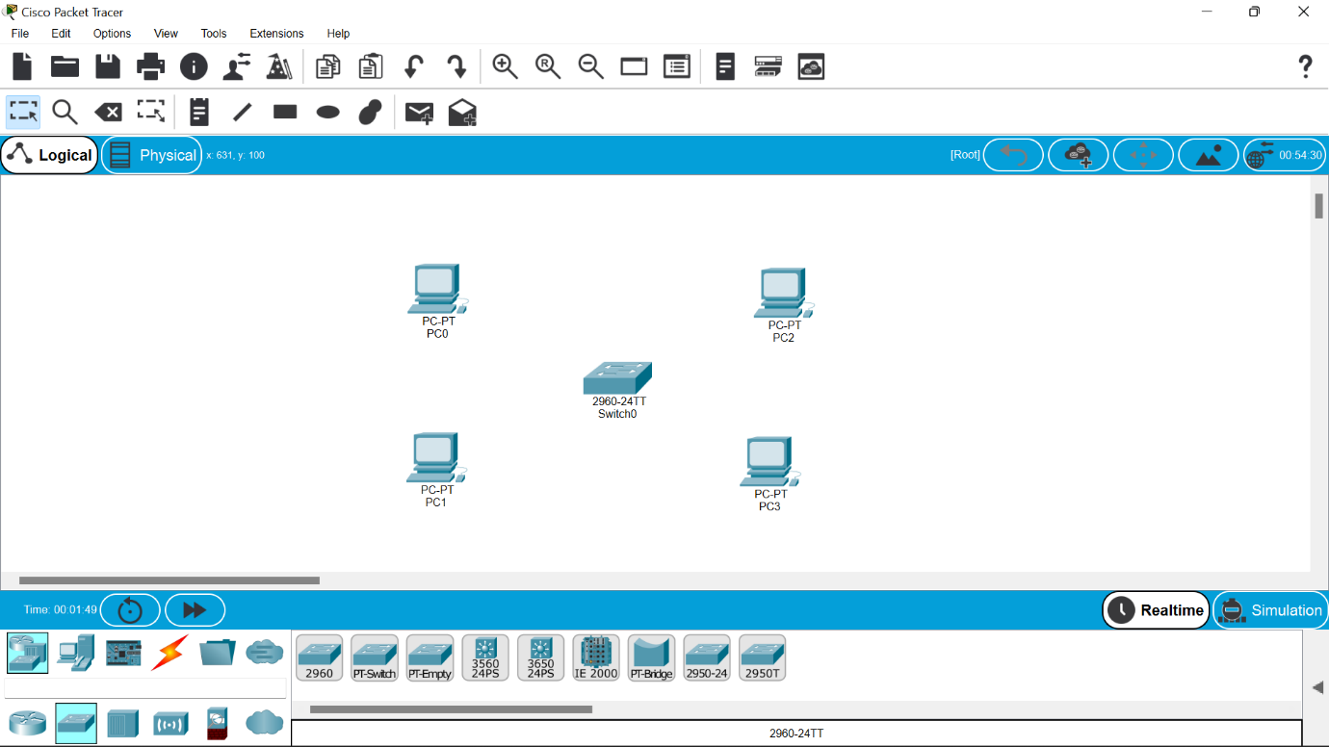

**5.select the straight line through cable and collect all the end devices to switch .**



**6.assign ip address to all the devices .**

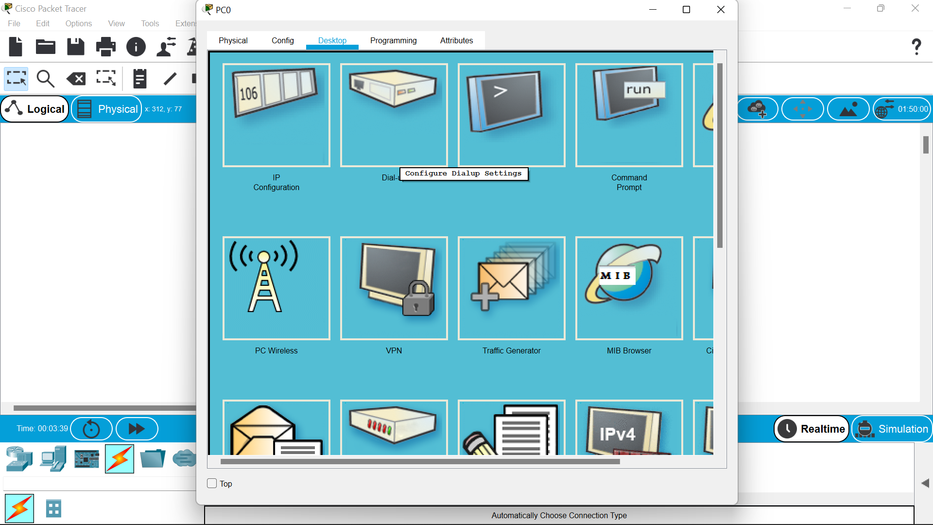

**7.to view the ip address we can go to command prompt and type ipconfigure for each particular.**

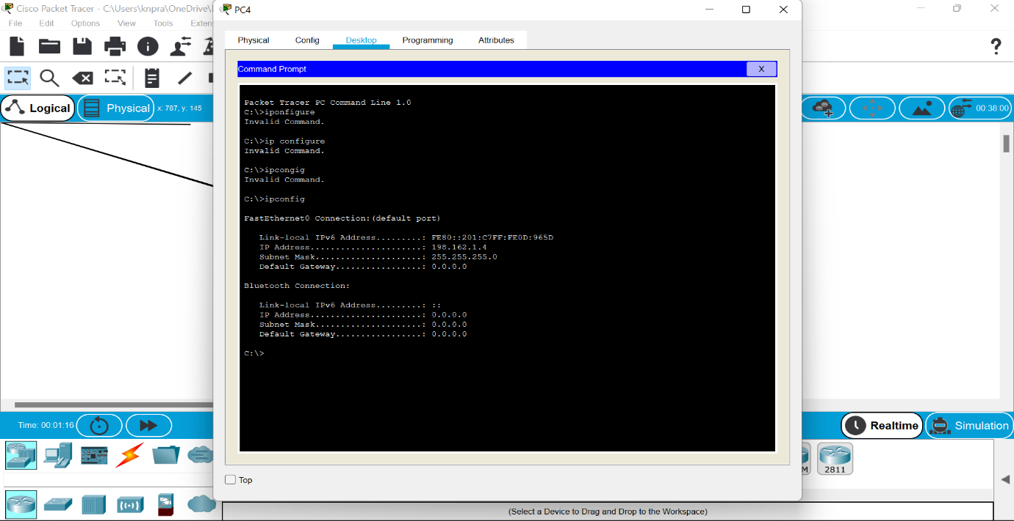

**8.we can also ping command to view the connections btwn devices.**

***Result:***

***Thus the establishment of configuration btwn network device has been done successfully.***

**EXPERIMENT NO—2,3::TOPLOGIES:**

*Aim :*

**Configuration of topologies using packet tracer**

**(bus,star ,ring, mesh,tree,hybrid)**

*Software/Apparatus required:*

Packet Tracer/End devices, bridge, connectors

**Procedure:**

Steps for building topology:

Step 1: Start Packet Tracer

Step 2: Choosing Devices and Connections

Step 3: Building the Topology – Adding Hosts

Step 4: Building the Topology – Connecting the Hosts to Switches

Step 5: Connect PCs to switch by first choosing Connections

Step 6: Configuring IP Addresses and Subnet Masks on the Hosts

Step 7: To confirm Data transfer between the devices

**STAR TOPOLOGY:**

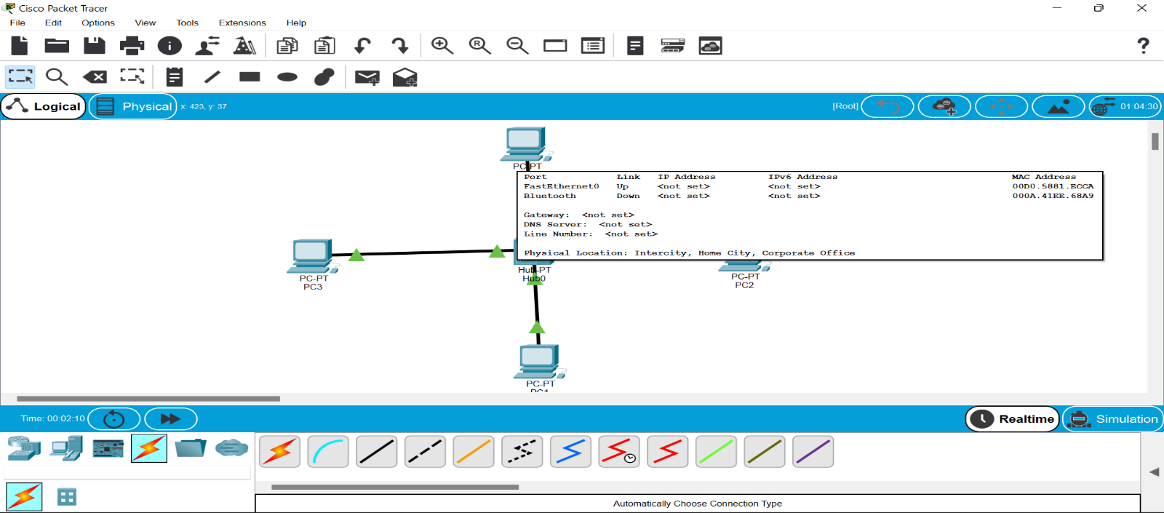

**BUS TOPOLOGY:**

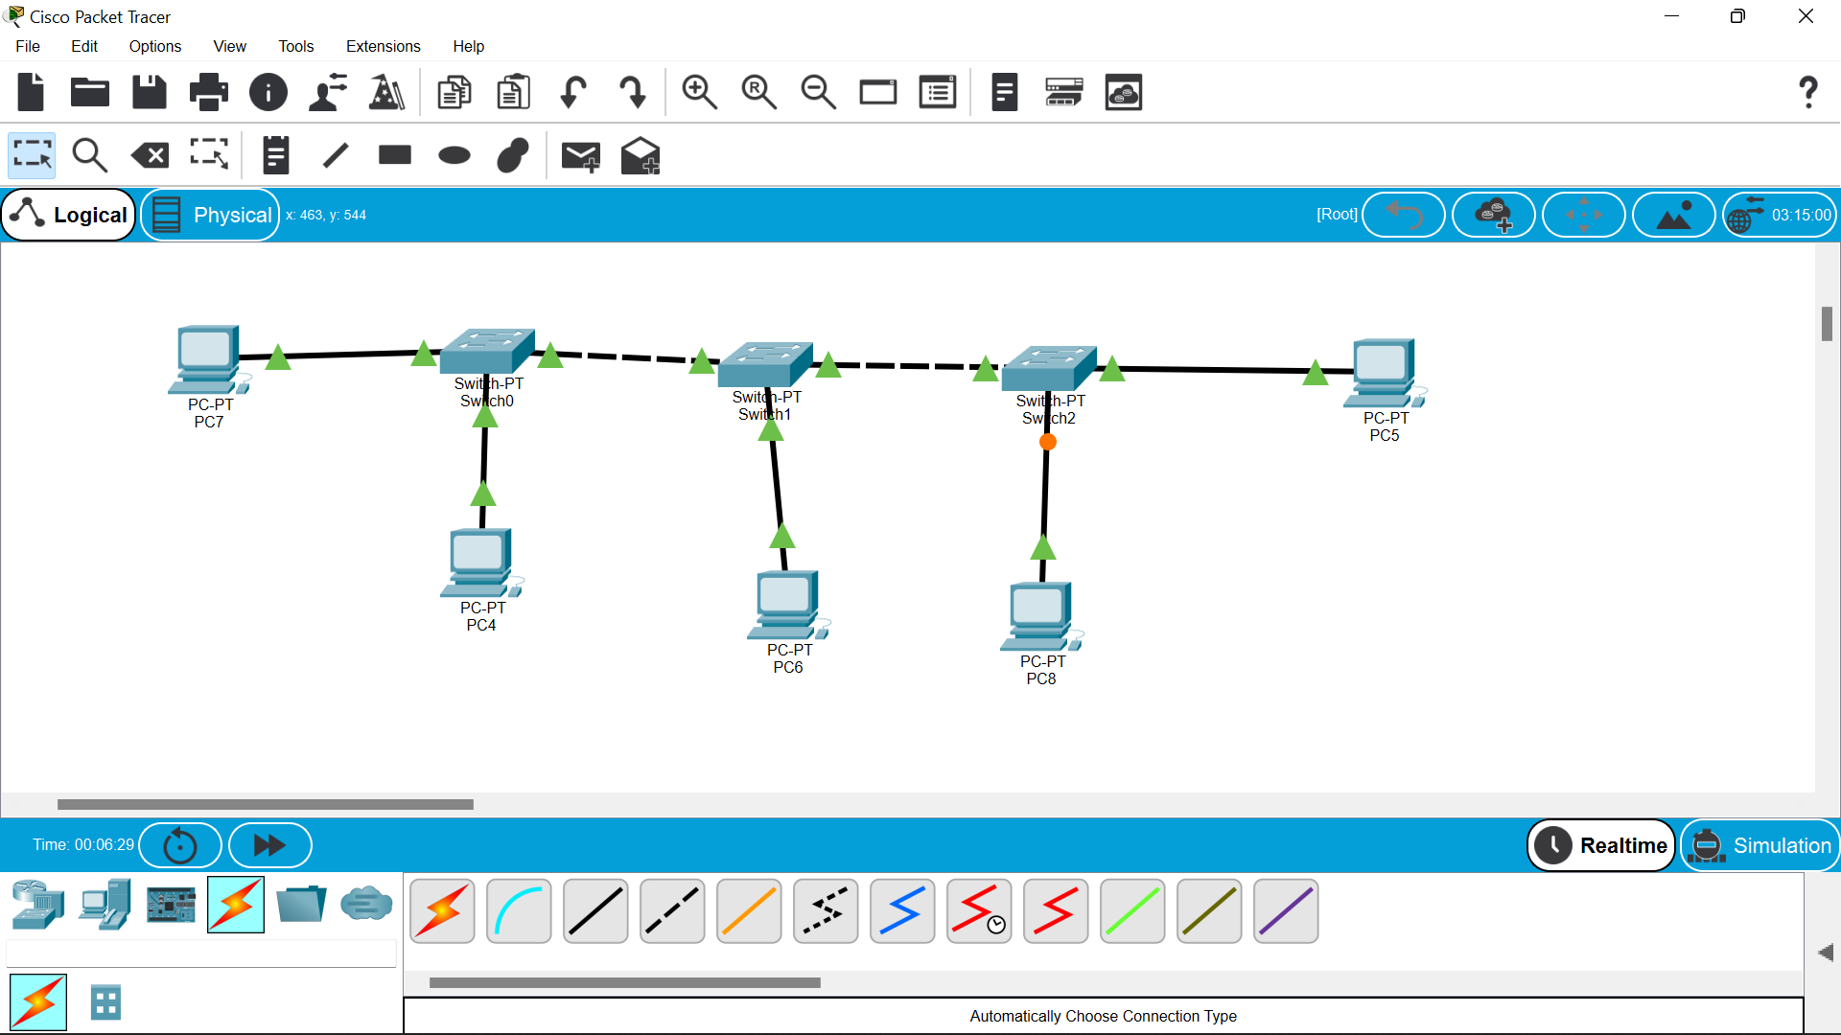

**RING TOPOLOGY:**

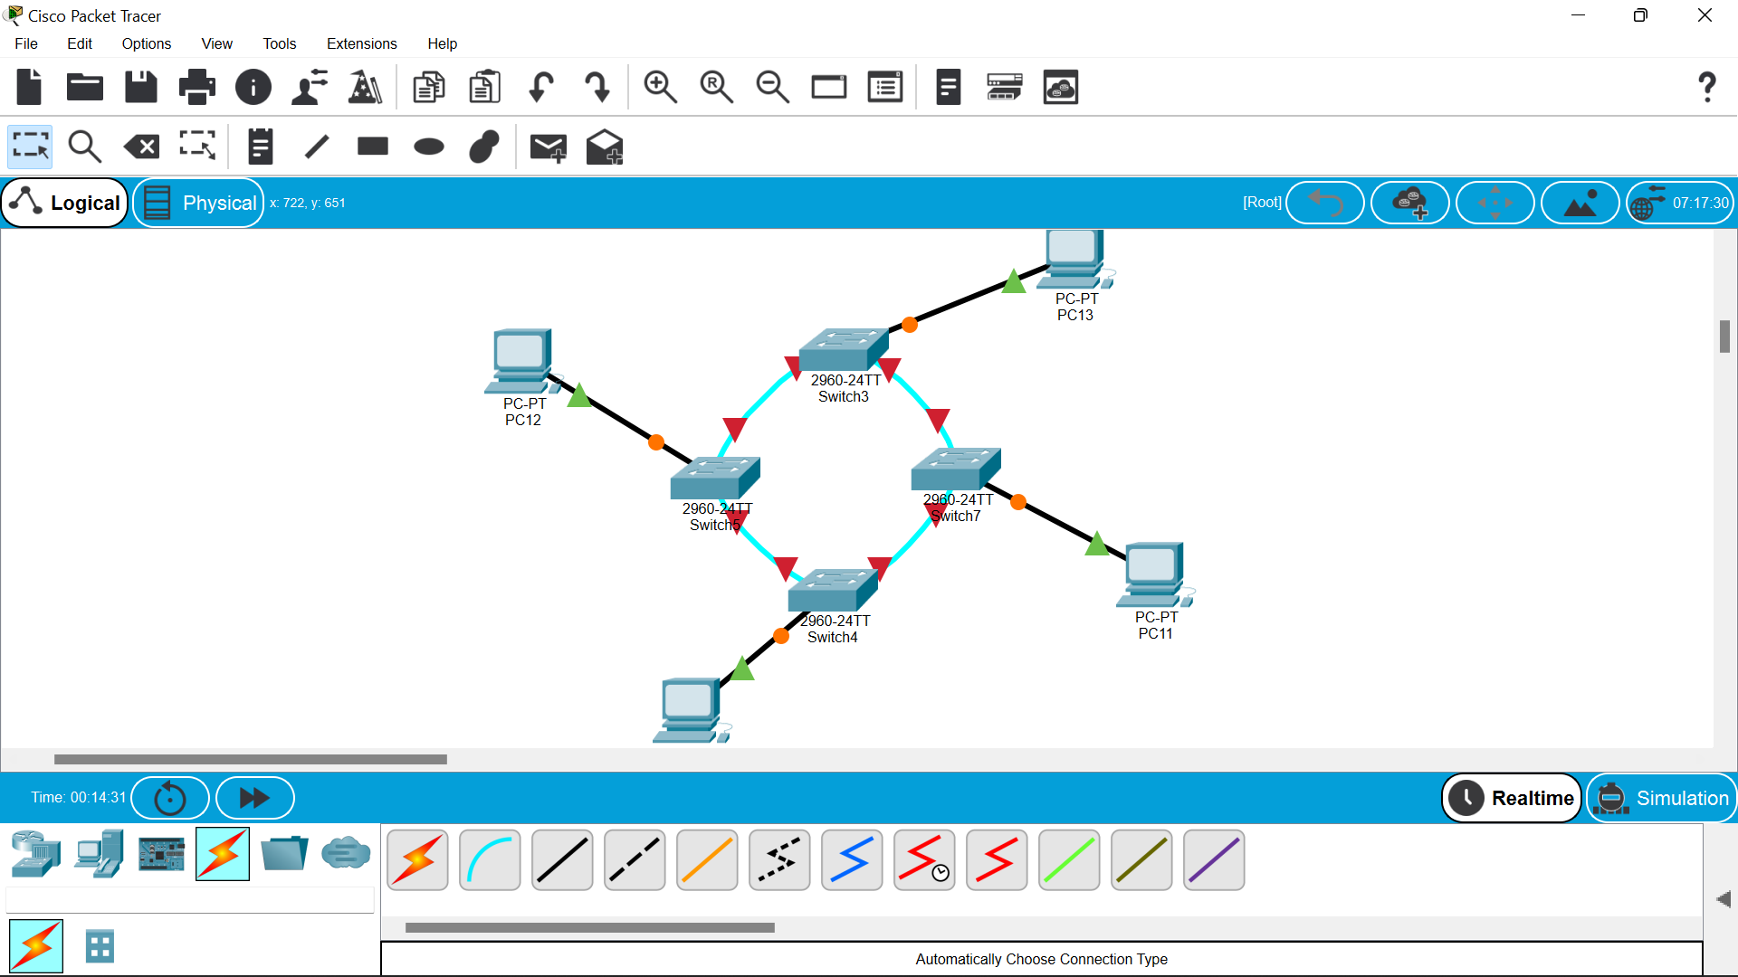

**MESH TOPOLOGY:**

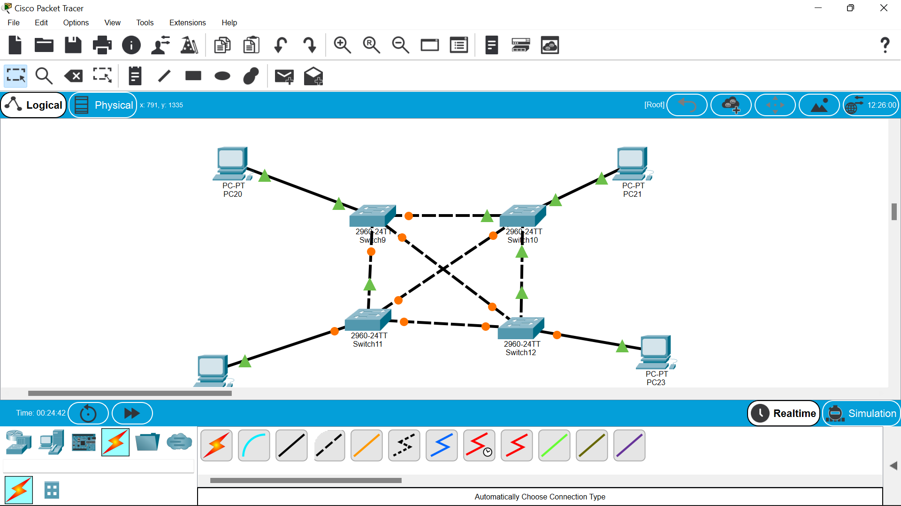

**TREE TOPOLOGY:**

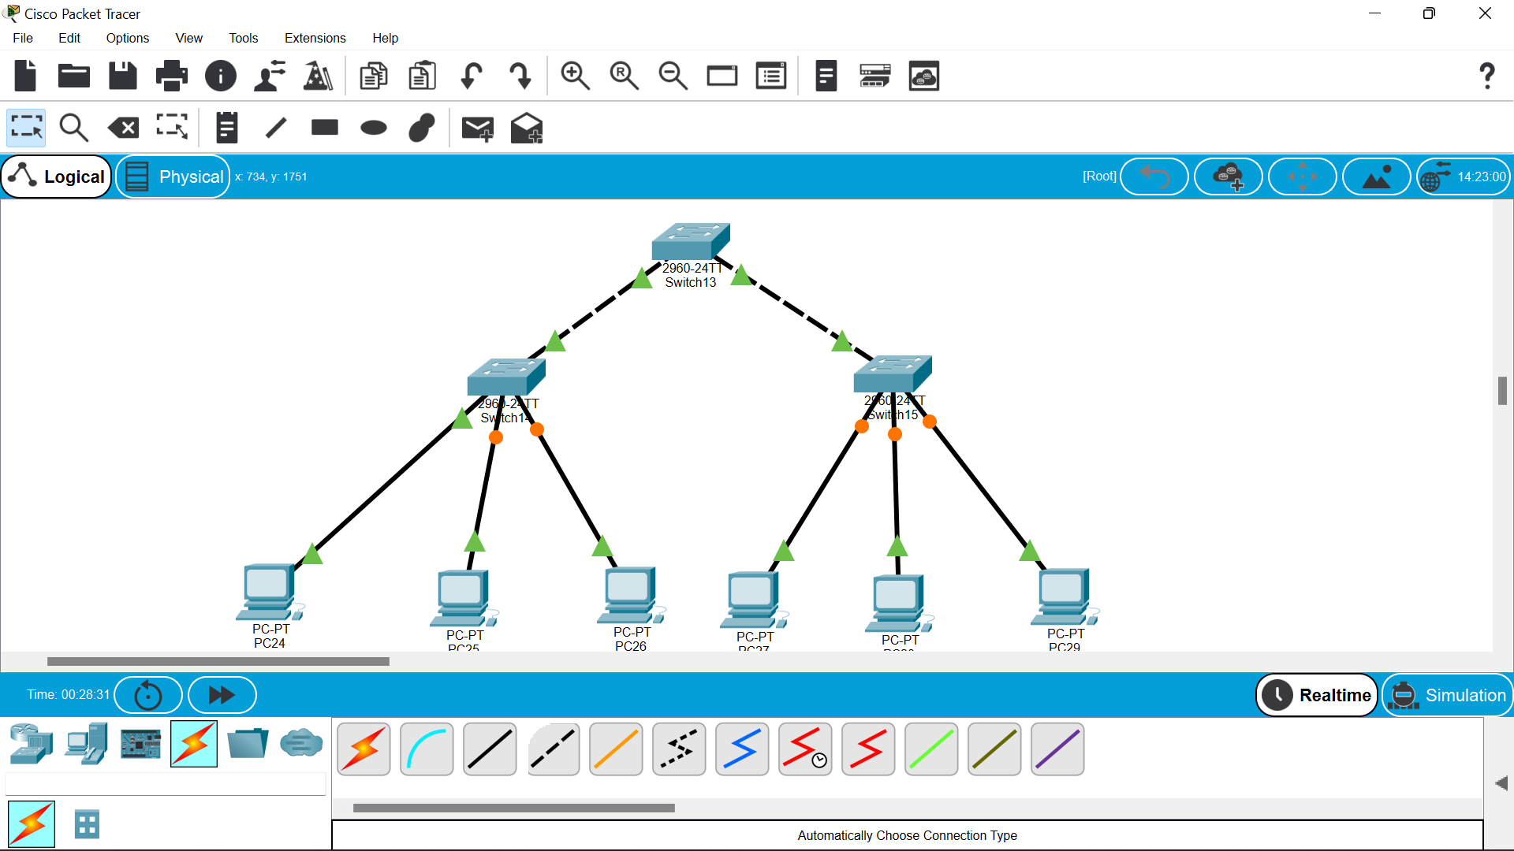

**HYBRID TOPOLOGY:**

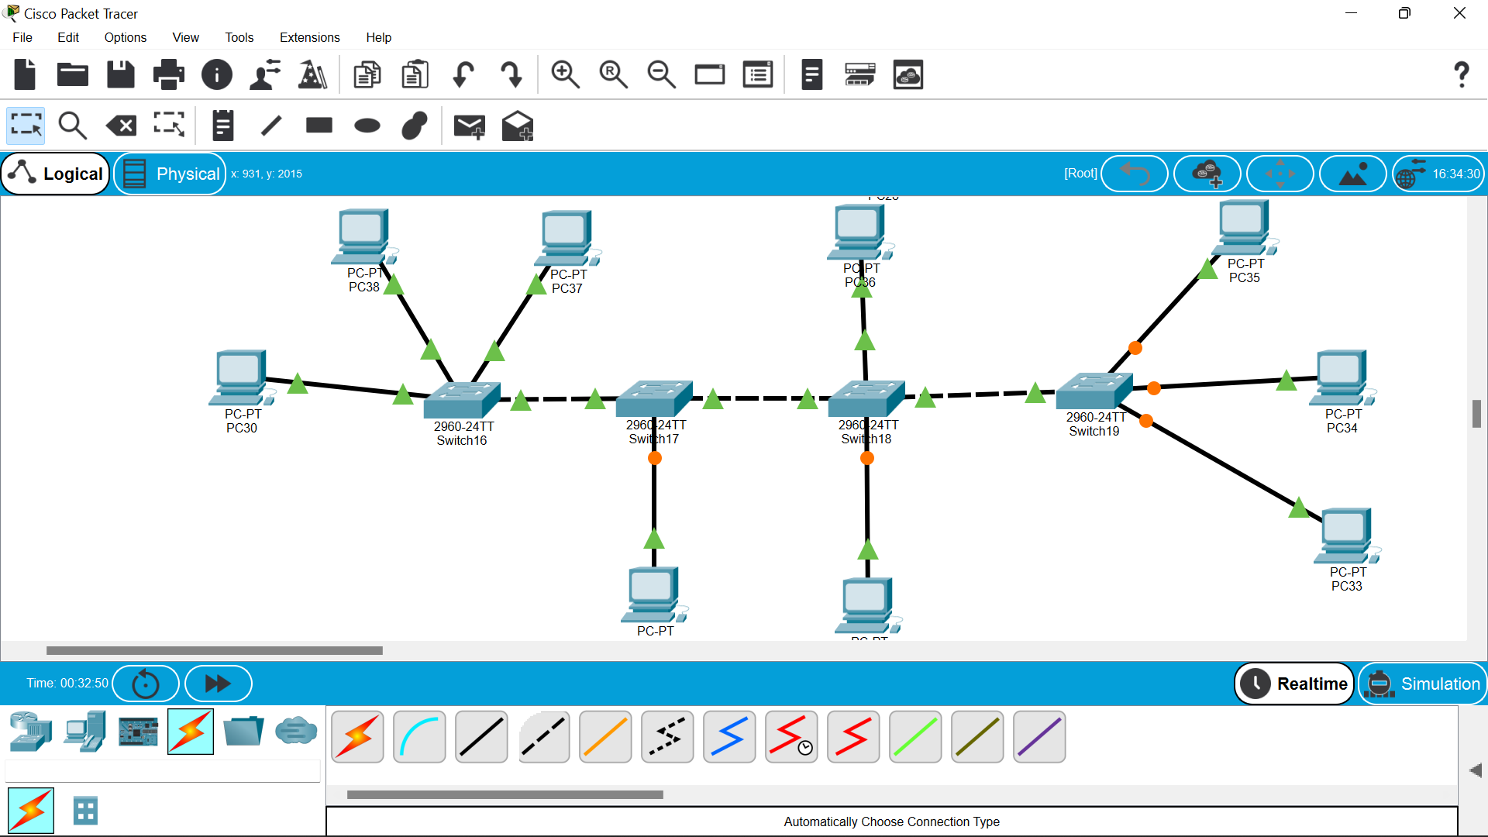

**Result:**

**Thus the configuration of the topologies had been done successfully.**

**EXPERIMENT NO –04:**

**AIM::**

**Data Link Layer Traffic Simulation using Packet Tracer Analysis of ARP**

**REQUIRMENTS::**

**Cisco packet tracer,hubs,switches.**

**PROCEDURE::**

**1.open the cisco tracer and drag the hub to the topology site.**

**2.then drag an two pc’s also on to the site .**

**3.server is also dragged to the work space.**

**4.now arrange them and establish the connections among them as shown below.**

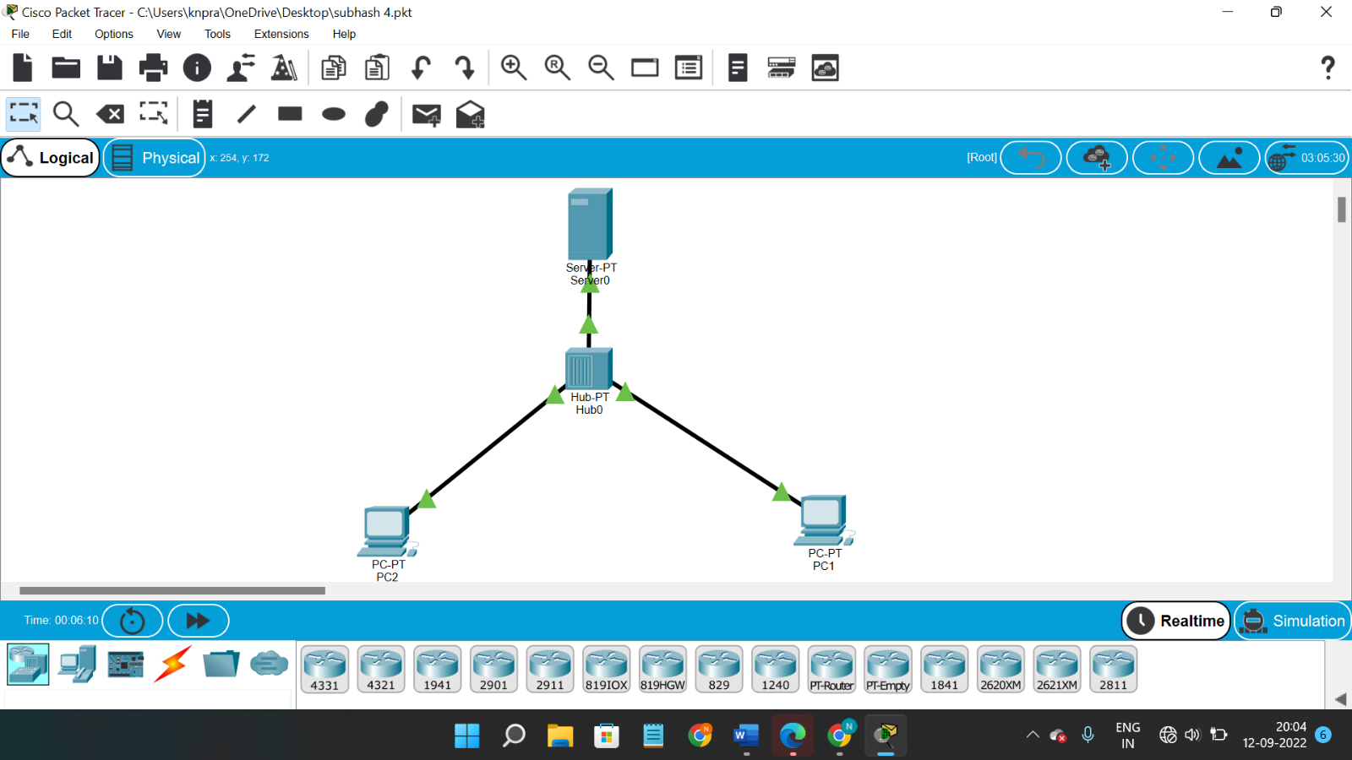

**5.then try to give them the ip address .**

**6.After giving the ip address ,you will find the msg symbol on the top of working space.select it and place on one pc,the select an other pc where you want to send data.**

**7.then start stimulation then you will be able to find the path of transmission of packet.as bellow.**

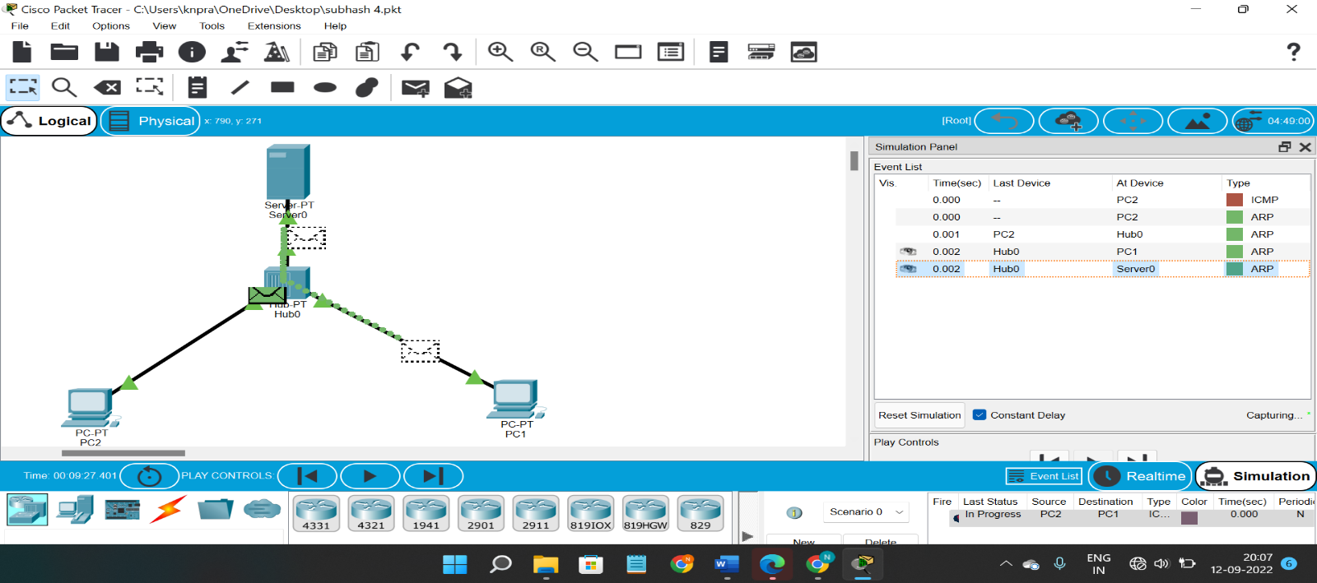

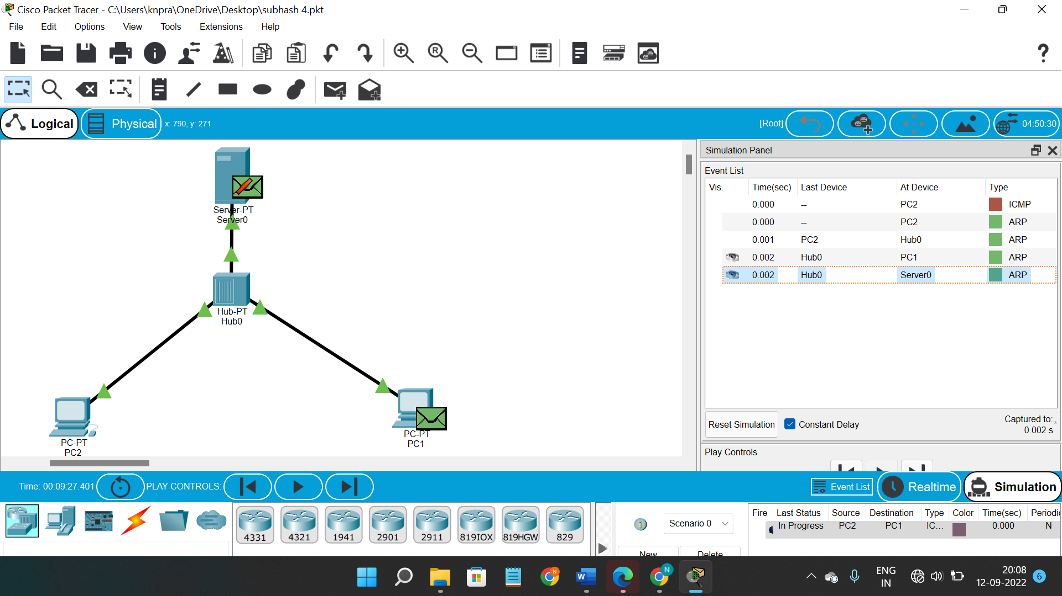

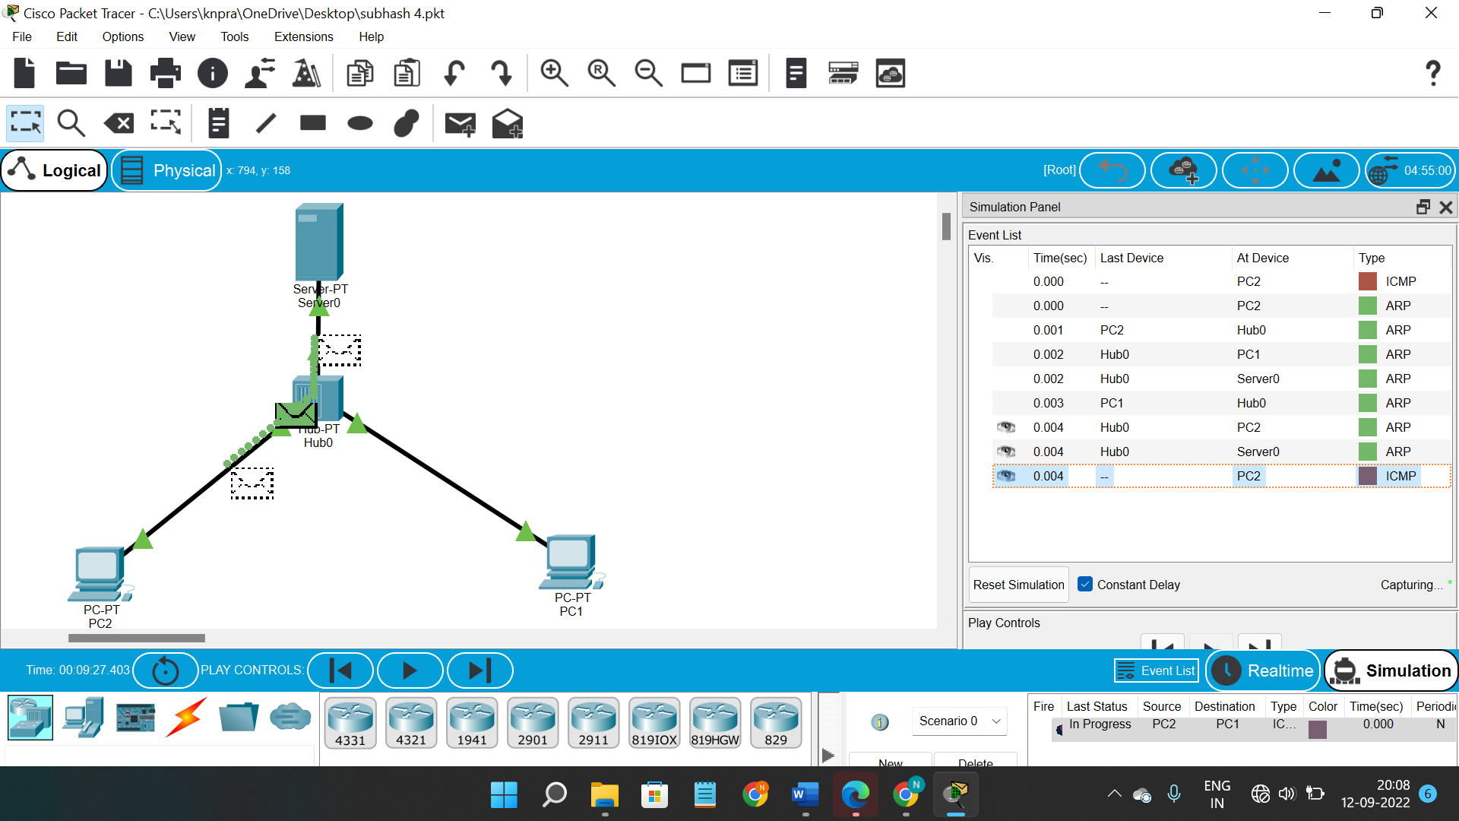

**Result ::**

**So finnaly if you look at the result the msg will be transferred clearly.**

**EXPERIMENT NO –06:**

Configuration of a simple static routing in packet tracer using a simple topology with two routers

**AIM::**

To Configure a router using packet tracer software and hence to transmit data between the devices in real time mode and simulation mode.

Software/Apparatus required:

Packet Tracer/End devices, Hubs, connectors.

Steps for building topology:

Step 1: Start Packet Tracer

Step 2: Choosing Devices and Connections

Step 3: Single click on the End Devices. Single click on the Generic Host. Place PC0, PC1 on topology area. Connect PCs to Switch 1. Similarly Place PC2, PC3 on topology area for receiver side Connect these PCs with switch 1 and 2 respectively through connecting wires. Select 2Routers and place the routers each one upon their switches . Connect these switches into router through connecting wires.

Step 3:Configuring IP Addresses, Gate Way and Subnet Masks on the Hosts

To start communication between the hosts IP Addresses, subnet Masks and Gate way had to be configured on the devices.

Click once on PCs. Choose the Config tab and click on FastEthernet0.

Type the IP address in its field. Based on router create gate way click on the subnet mask. It will be generated automatically.

Step 4: Verifying Connectivity in Realtime Mode Be sure you are in Realtime mode.

Select the Add Simple PDU tool used to ping devices.

Click once on PC0, then once on PC3. The PDU Last Status should show as Successful.

Step 5: Verifying Connectivity in Simulation Mode

Be sure you are in Simulation mode.

Deselect all filters (All/None) and select only ICMP.

Select the Add Simple PDU tool used to ping devices Click once on PC0, then once on PC3.

Continue clicking Capture/Forward button until the ICMP ping is completed.

You should see the ICMP messages move between the hosts, hub and switch.

The PDU Last Status should show as Successful.

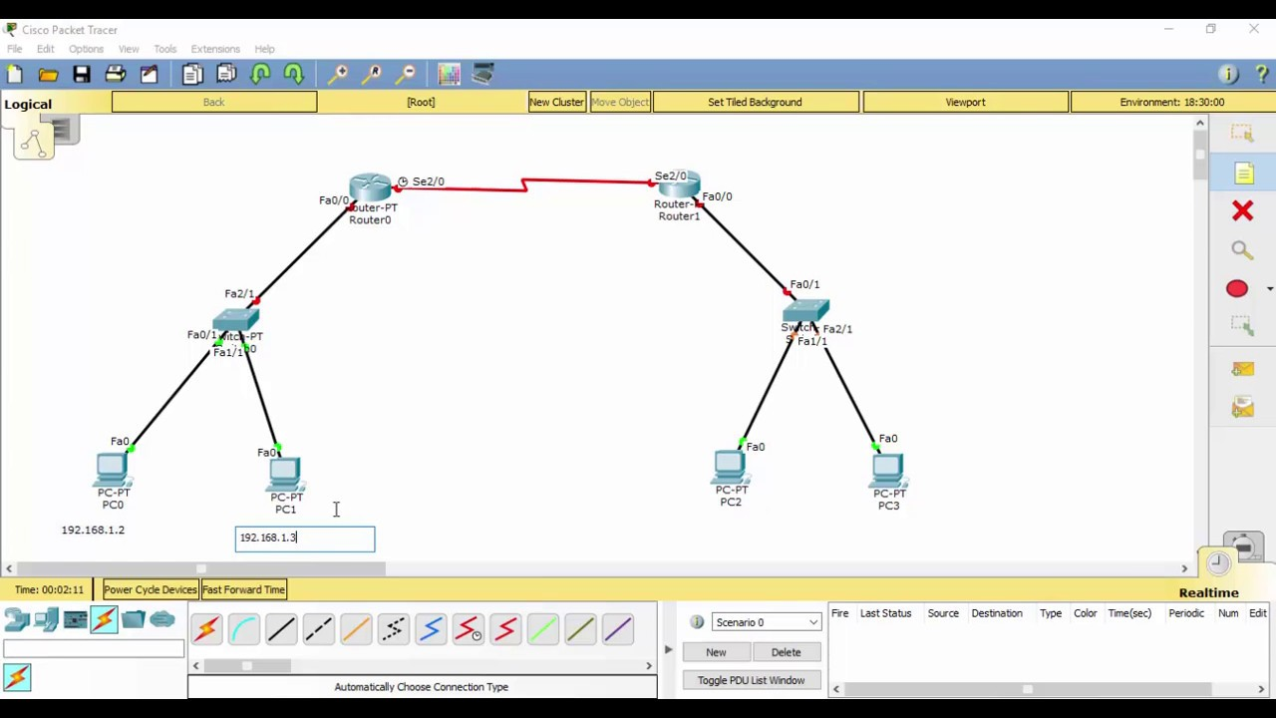

Result:

Thus Configuration of a simple static routing in packet tracer using a simple topology with two routers was done successfully

**EXPERIMENT NO –06:**

**Dynamic Routing using Packet Tracer (Distance vector).**

**AIM::**

To Configure a network using distance vector routing (Routing information protocol) using packet tracer software and hence to transmit data between the devices in real time mode as well as simulation mode.   
Software/Apparatus required:

Packet Tracer/End devices, Hubs, connectors

Steps for building topology:

Step 1: Start Packet Tracer

Step 2: Choosing Devices and Connections

Step 3: Single click on the End Devices. Single click on the Generic Host. Place PC0, PC1 on topology area. Connect PCs to Switch 1. Similarly Place PC2, PC3 on topology area for receiver side. Connect these PCs with switch 1 and 2 respectively through connecting wires. Select Router1 and Router 2 and place the router 1, 2 between two switches. Connect these switches into router through connecting wires.

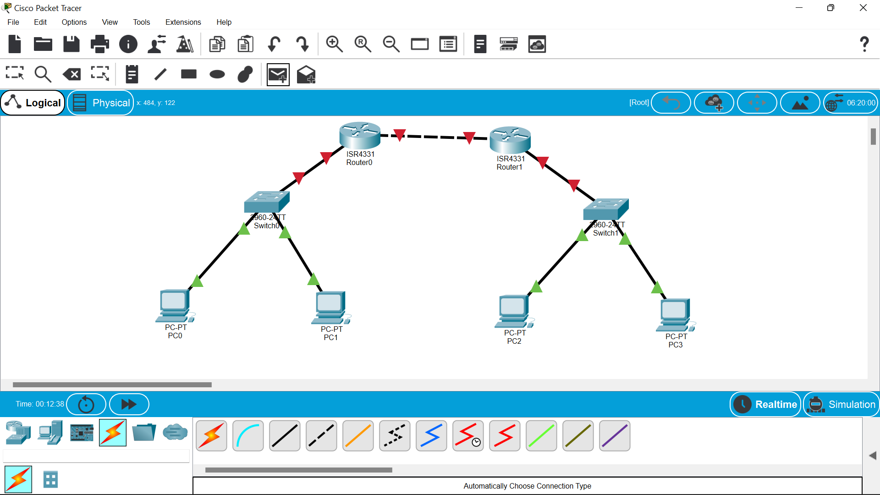

Step 3:Configuring IP Addresses, Gate Way and Subnet Masks on the Hosts

To start communication between the hosts IP Addresses, subnet Masks and Gate way had to be configured on the devices. Click once on PCs. Choose the Config tab and click on FastEthernet0. Type the IP address in its field. Based on router create gate way click on the subnet mask. It will be generated automatically

Step 4: Verifying Connectivity in Realtime Mode Be sure you are in Realtime mode.

Select the Add Simple PDU tool used to ping devices. Click once on PC0, then once on PC3. The PDU Last Status should show as Successful.

Step 5:Verifying Connectivity in Simulation Mode Be sure you are in Simulation mode.

Deselect all filters (All/None) and select only ICMP. Select the Add Simple PDU tool used to ping devices Click once on PC0, then once on PC3. Continue clicking Capture/Forward button until the ICMP ping is completed. You should see the ICMP messages move between the hosts, hub and switch. The PDU Last Status should show as Successful

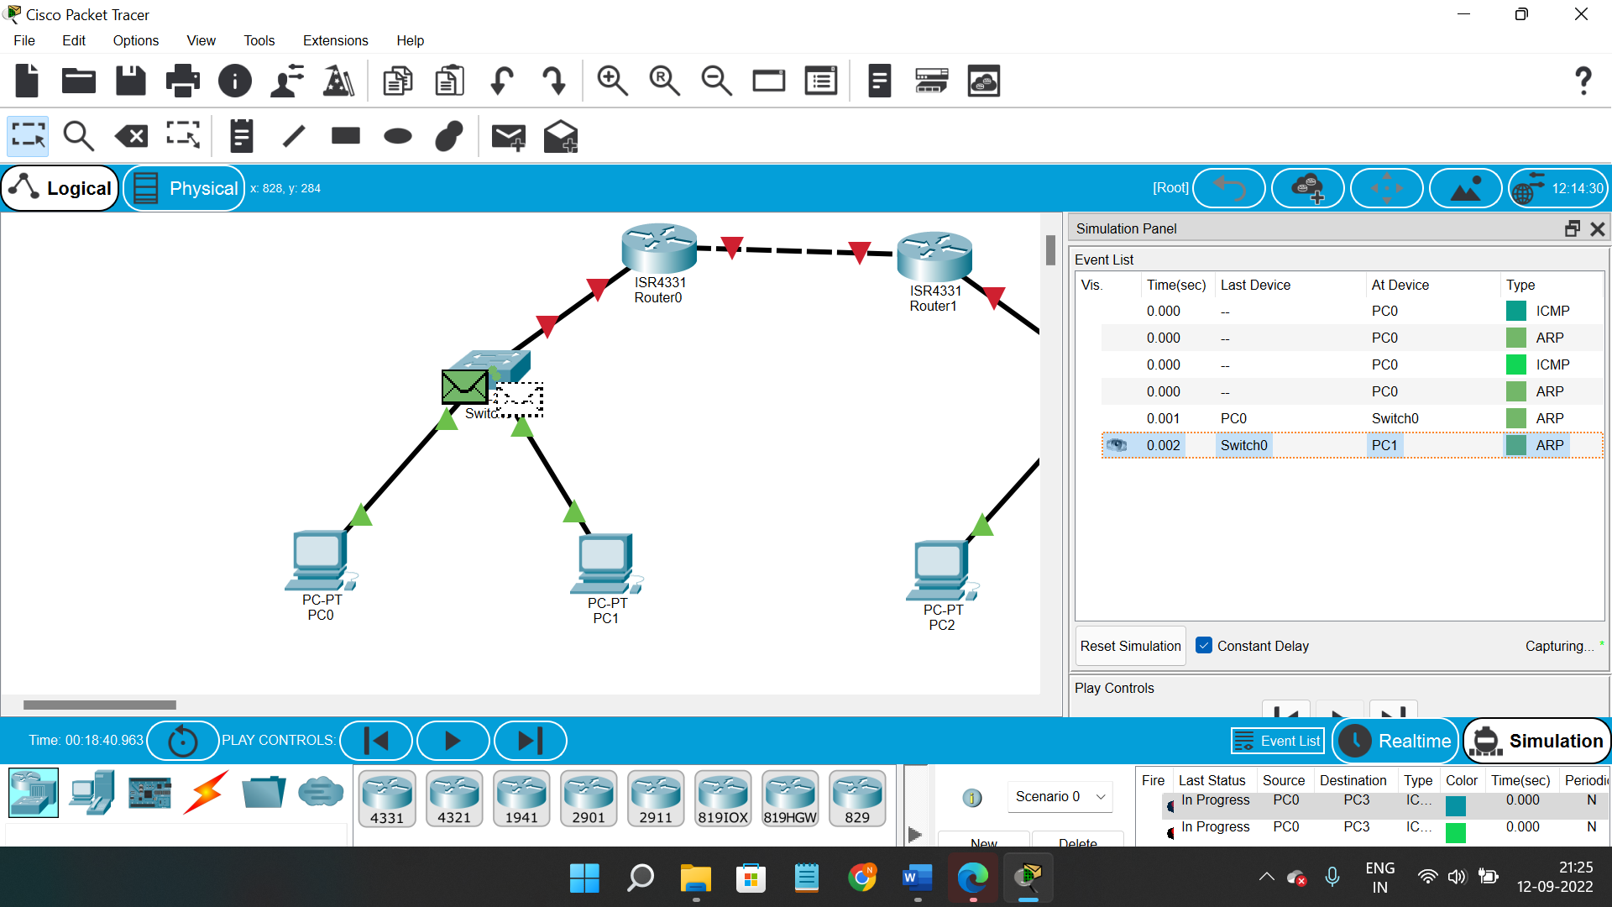

Result: Thus the Configuration of Dynamic Routing – RIP in Packet Tracer.